Network Portion
# Source: Chatgpt (GPT-5-Mini) at [1/18/2026]
In an IP address, the network portion is the part that identifies which network the address belongs to. It’s determined by the subnet mask or CIDR prefix length.

🧠 Simple Definition:
# Source: Chatgpt (GPT-5-Mini) at [1/18/2026]
The network portion is the starting part of an IP address that tells routers which network or subnet it belongs to.
The rest of the IP is called the host portion, which identifies individual devices (hosts) within that network.

🧾 Example:
# Source: Chatgpt (GPT-5-Mini) at [1/18/2026]
Let’s take this IP and CIDR block:
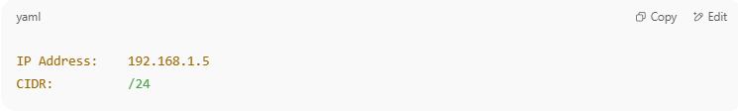
IP Address: 192.168.1.5
CIDR: /24

- /24 means the first 24 bits are the network portion
- The remaining 8 bits are for host addresses
Breakdown (in binary):
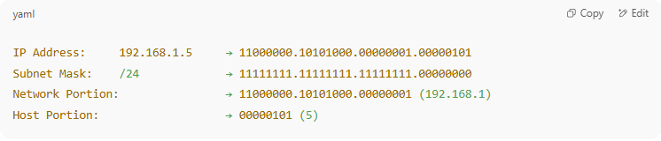
IP Address: 192.168.1.5 → 11000000.10101000.00000001.00000101
Subnet Mask: /24 → 11111111.11111111.11111111.00000000
Network Portion: → 11000000.10101000.00000001 (192.168.1)
Host Portion: → 00000101 (5)

- Network portion: 192.168.1.0
- Host portion: 5
So, 192.168.1.5 belongs to the network 192.168.1.0/24

📦 Real-World Analogy:
# Source: Chatgpt (GPT-5-Mini) at [1/18/2026]
Think of an address:
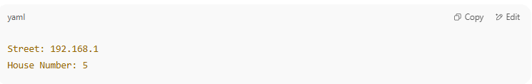
Street: 192.168.1
House Number: 5

- Street = network portion (same for everyone on that street)
- House number = host portion (unique to each house)

🧮 Summary Table:
# Source: Chatgpt (GPT-5-Mini) at [1/18/2026]
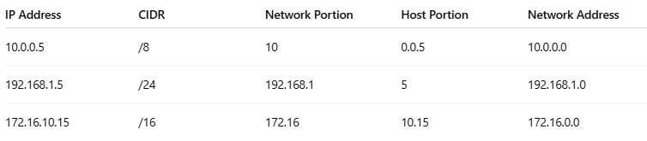

IP Address | CIDR | Network Portion | Host Portion | Network Address
10.0.0.5 | /8 | 10 | 0.0.5 | 10.0.0.0
192.168.1.5 | /24 | 192.168.1 | 5 | 192.168.1.0
172.16.10.15 | /16 | 172.16 | 10.15 | 172.16.0.0

✅ Summary
# Source: Chatgpt (GPT-5-Mini) at [1/18/2026]
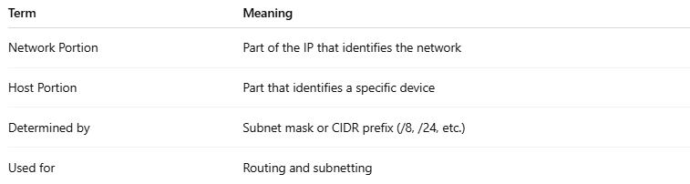
Term | Meaning
Network Portion | Part of the IP that identifies the network
Host Portion | Part that identifies a specific device
Determined by | Subnet mask or CIDR prefix (/8, /24, etc.)
Used for | Routing and subnetting

